Adrian Grimm

Create/Alter Lab

9/18/2018

CREATE DATABASE DBTest

ON

(NAME='DBTest',

FILENAME='C:\Program Files\Microsoft SQL Server\MSSQL11.SQLSERVER2012\MSSQL\Data\DBTest.mdf',

SIZE=12,

MAXSIZE=50,

FILEGROWTH=2)

LOG ON

(NAME='DBTestLog',

FILENAME='C:\Program Files\Microsoft SQL Server\MSSQL11.SQLSERVER2012\MSSQL\Data\DBTest.idf',

SIZE=6MB,

MAXSIZE=30MB,

FILEGROWTH=5MB);



USE DBTest;



CREATE TABLE DBTestTable (

TestID int IDENTITY NOT NULL,

TestName varchar(25) NOT NULL

);

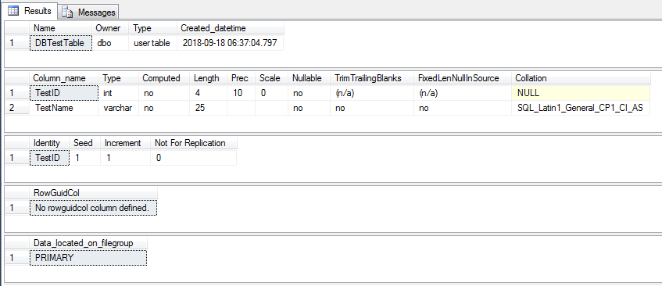

ALTER TABLE DBTestTable

ADD

TestDate datetime NOT NULL default 2007-01-01;

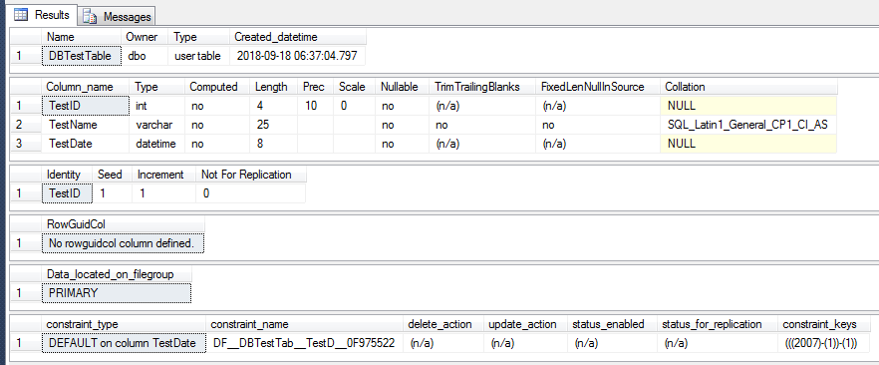

USE [DBTest]

GO

/****** Object: Table [dbo].[DBTestTable] Script Date: 9/18/2018 7:08:54 AM ******/

SET ANSI_NULLS ON

GO

SET QUOTED_IDENTIFIER ON

GO

SET ANSI_PADDING ON

GO

CREATE TABLE [dbo].[DBTestTable](

[testID] [int] IDENTITY(1,1) NOT NULL,

[testName] [varchar](25) NOT NULL,

[testDate] [datetime] NOT NULL

) ON [PRIMARY]

GO

SET ANSI_PADDING OFF

GO

ALTER TABLE [dbo].[DBTestTable] ADD CONSTRAINT [DF_DBTestTable_testDate] DEFAULT (((2007)-(1))-(1)) FOR [testDate]

GO

USE [DBTest]

GO

/****** Object: Table [dbo].[DBTestTable] Script Date: 9/18/2018 11:18:26 AM ******/

DROP TABLE [dbo].[DBTestTable]

GO

USE [master]

GO

/****** Object: Database [DBTest] Script Date: 9/18/2018 11:19:31 AM ******/

DROP DATABASE [DBTest]

GO